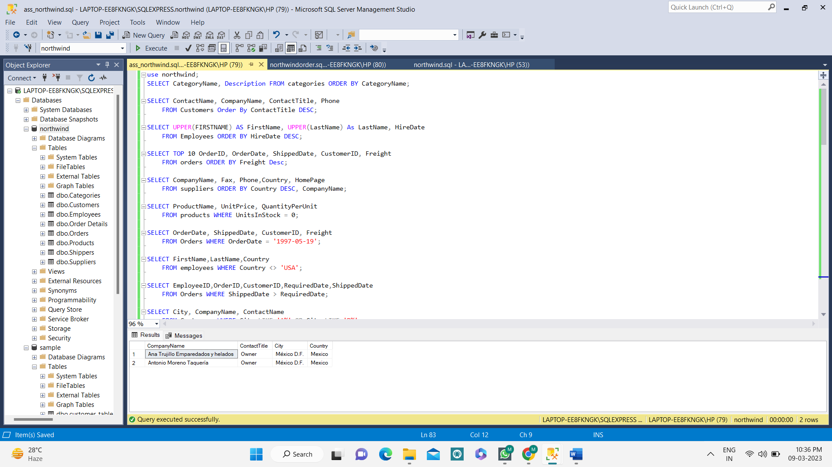**DQL Basics**

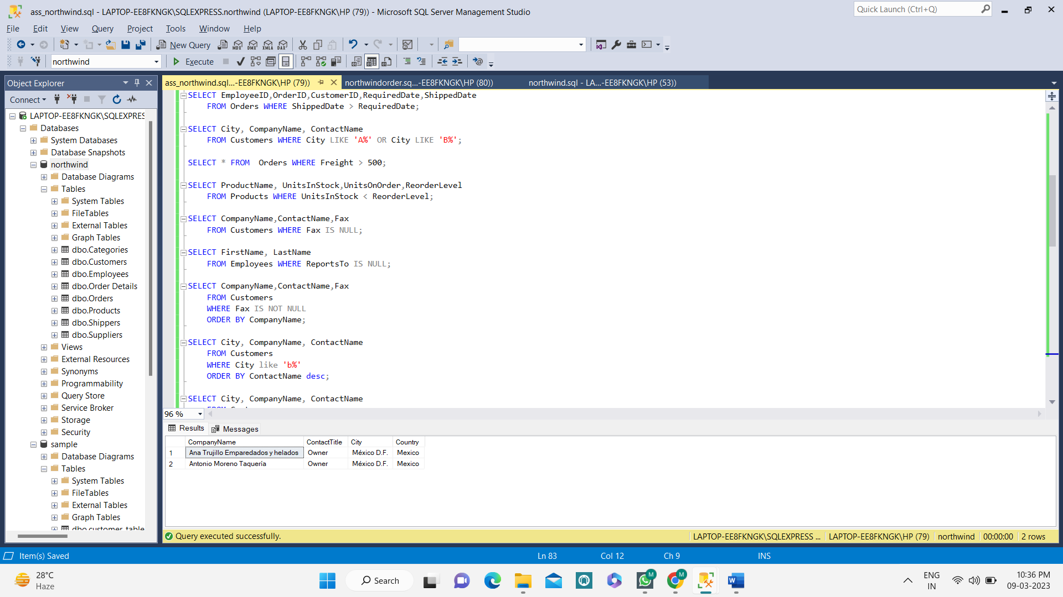

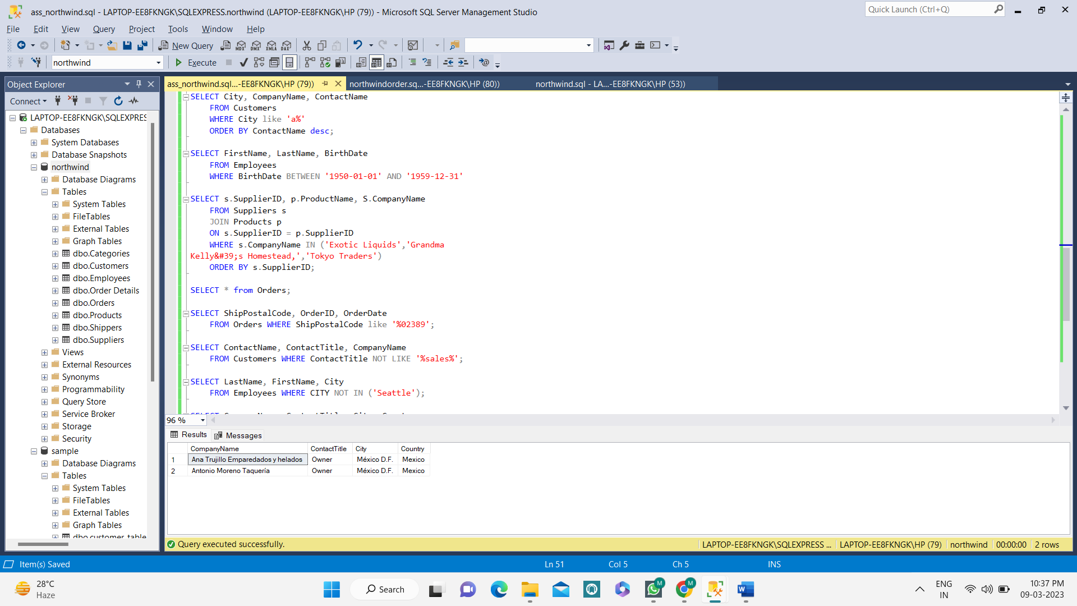

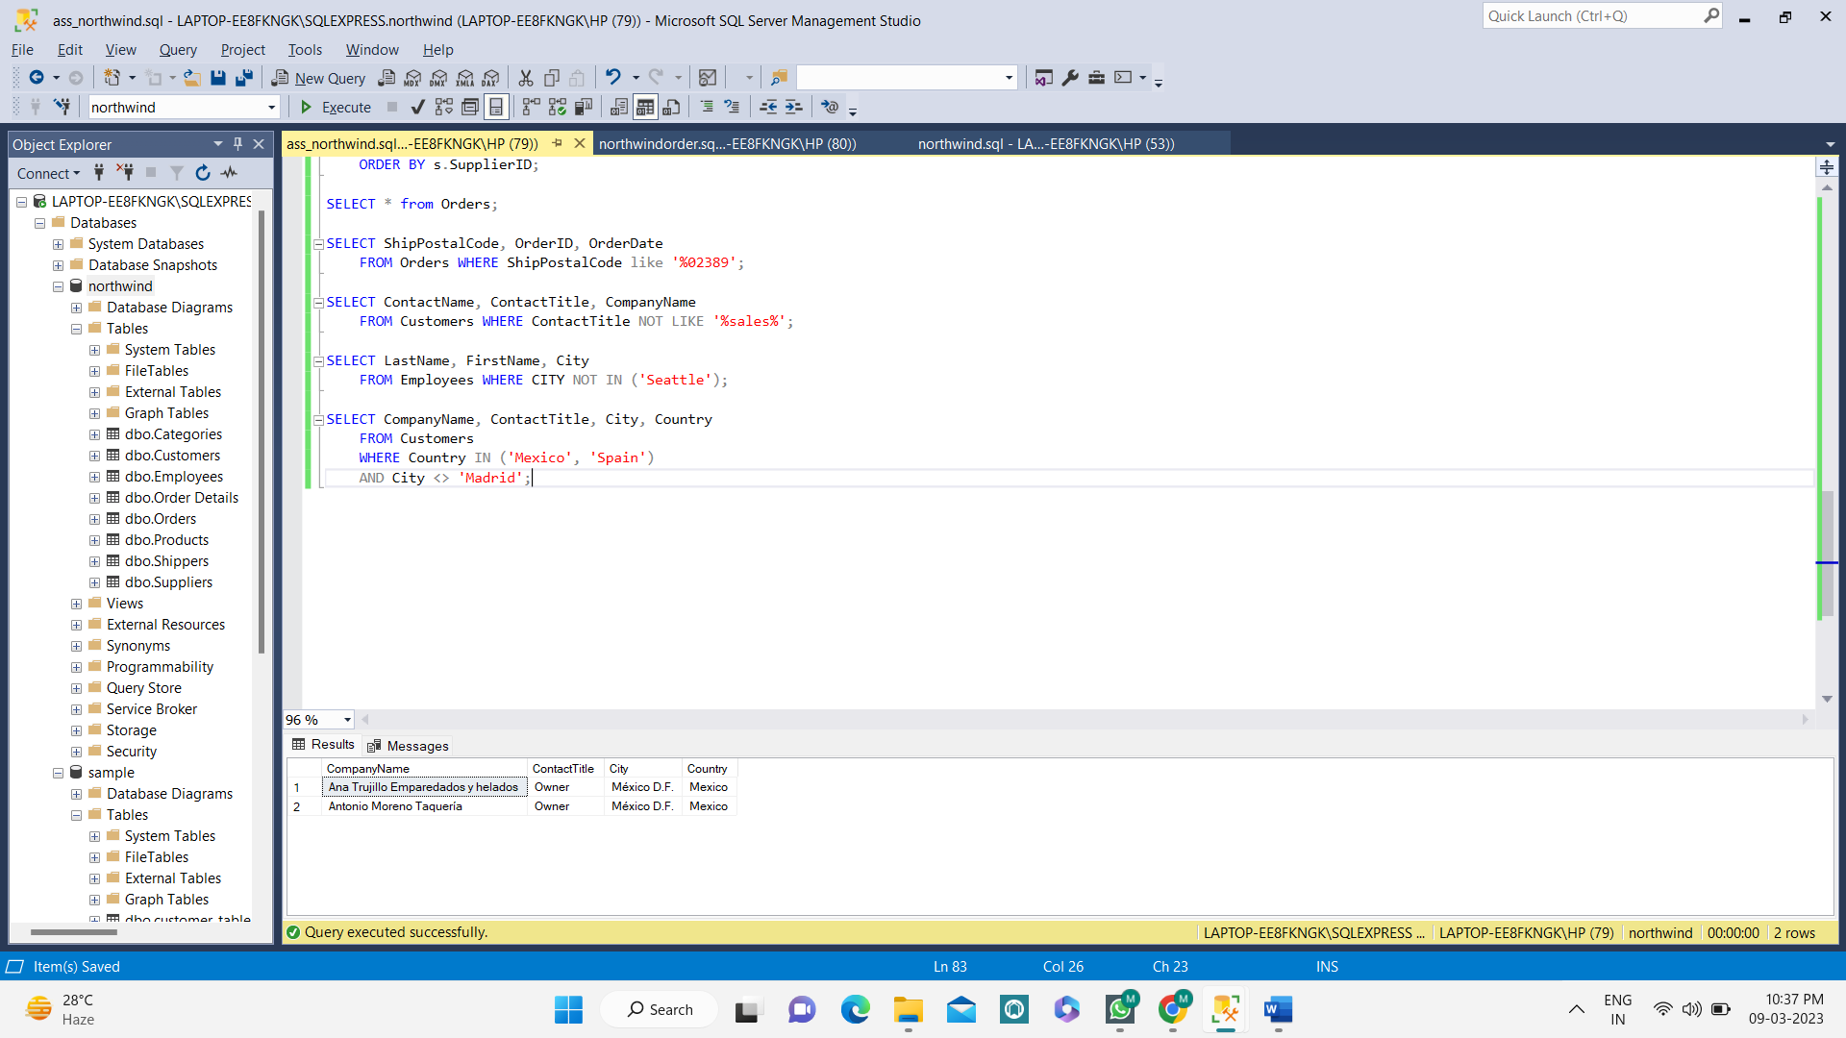

**QUERY:**

use northwind;

SELECT CategoryName, Description FROM categories ORDER BY CategoryName;

SELECT ContactName, CompanyName, ContactTitle, Phone

FROM Customers Order By ContactTitle DESC;

SELECT UPPER(FIRSTNAME) AS FirstName, UPPER(LastName) As LastName, HireDate

FROM Employees ORDER BY HireDate DESC;

SELECT TOP 10 OrderID, OrderDate, ShippedDate, CustomerID, Freight

FROM orders ORDER BY Freight Desc;

SELECT CompanyName, Fax, Phone,Country, HomePage

FROM suppliers ORDER BY Country DESC, CompanyName;

SELECT ProductName, UnitPrice, QuantityPerUnit

FROM products WHERE UnitsInStock = 0;

SELECT OrderDate, ShippedDate, CustomerID, Freight

FROM Orders WHERE OrderDate = '1997-05-19';

SELECT FirstName,LastName,Country

FROM employees WHERE Country <> 'USA';

SELECT EmployeeID,OrderID,CustomerID,RequiredDate,ShippedDate

FROM Orders WHERE ShippedDate > RequiredDate;

SELECT City, CompanyName, ContactName

FROM Customers WHERE City LIKE 'A%' OR City LIKE 'B%';

SELECT * FROM Orders WHERE Freight > 500;

SELECT ProductName, UnitsInStock,UnitsOnOrder,ReorderLevel

FROM Products WHERE UnitsInStock < ReorderLevel;

SELECT CompanyName,ContactName,Fax

FROM Customers WHERE Fax IS NULL;

SELECT FirstName, LastName

FROM Employees WHERE ReportsTo IS NULL;

SELECT CompanyName,ContactName,Fax

FROM Customers

WHERE Fax IS NOT NULL

ORDER BY CompanyName;

SELECT City, CompanyName, ContactName

FROM Customers

WHERE City like 'b%'

ORDER BY ContactName desc;

SELECT City, CompanyName, ContactName

FROM Customers

WHERE City like 'a%'

ORDER BY ContactName desc;

SELECT FirstName, LastName, BirthDate

FROM Employees

WHERE BirthDate BETWEEN '1950-01-01' AND '1959-12-31'

SELECT s.SupplierID, p.ProductName, S.CompanyName

FROM Suppliers s

JOIN Products p

ON s.SupplierID = p.SupplierID

WHERE s.CompanyName IN ('Exotic Liquids','Grandma

Kelly&#39;s Homestead,','Tokyo Traders')

ORDER BY s.SupplierID;

SELECT * from Orders;

SELECT ShipPostalCode, OrderID, OrderDate

FROM Orders WHERE ShipPostalCode like '%02389';

SELECT ContactName, ContactTitle, CompanyName

FROM Customers WHERE ContactTitle NOT LIKE '%sales%';

SELECT LastName, FirstName, City

FROM Employees WHERE CITY NOT IN ('Seattle');

SELECT CompanyName, ContactTitle, City, Country

FROM Customers

WHERE Country IN ('Mexico', 'Spain')

AND City <> 'Madrid';

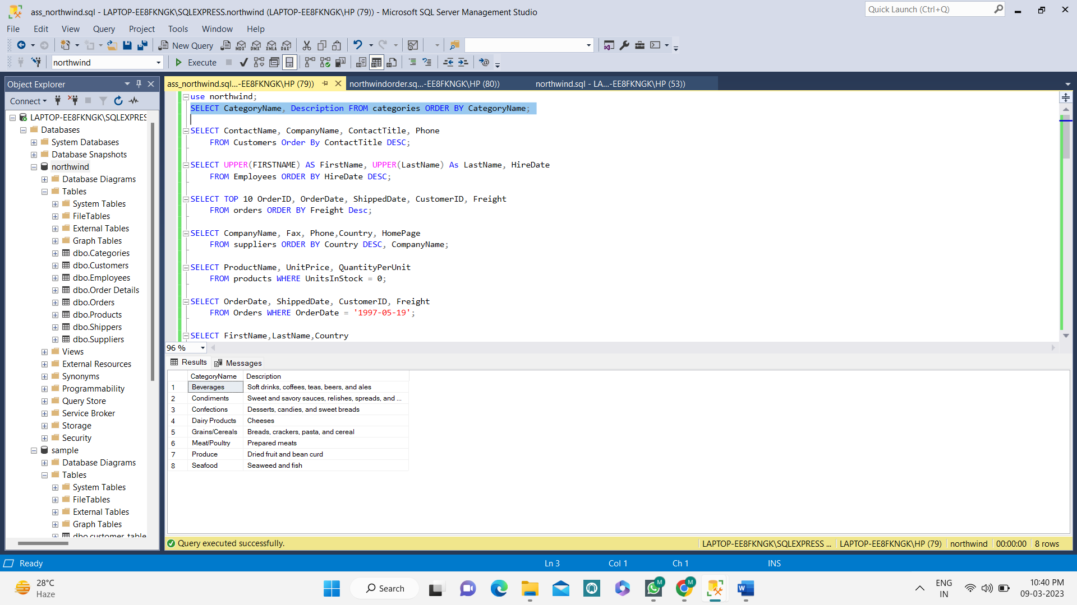**OUTPUT:**

